Knife Farm (9610561918) - decline diagnosis
LiveOps Analytics, 9 August 2026. Based on 129 days of history, 1 April to 7 August.

Short version
The game peaked around 1 May at roughly 769,000 daily players. It is at about 46,000 now, down 94% in fourteen weeks. Revenue has gone the same way, from about R$13.3M in the last week of April to R$520K now.
This did not happen in one drop. Roblox gave the game a lot of reach three times and pulled it back three times, and each peak was lower than the one before it.
The reason is the same every time and it is not a bug. Day 1 retention is fine and always has been, sitting between 16% and 25% for the whole four months. Everything after day 1 is not. Day 7 retention started at 4.5% and is 1.3% now. Day 30 started at 2.7% and is 0.2%. So Roblox sends players, the game hooks them for a day, almost nobody is still there a week later, and Roblox stops sending players. Then it repeats from a lower base.
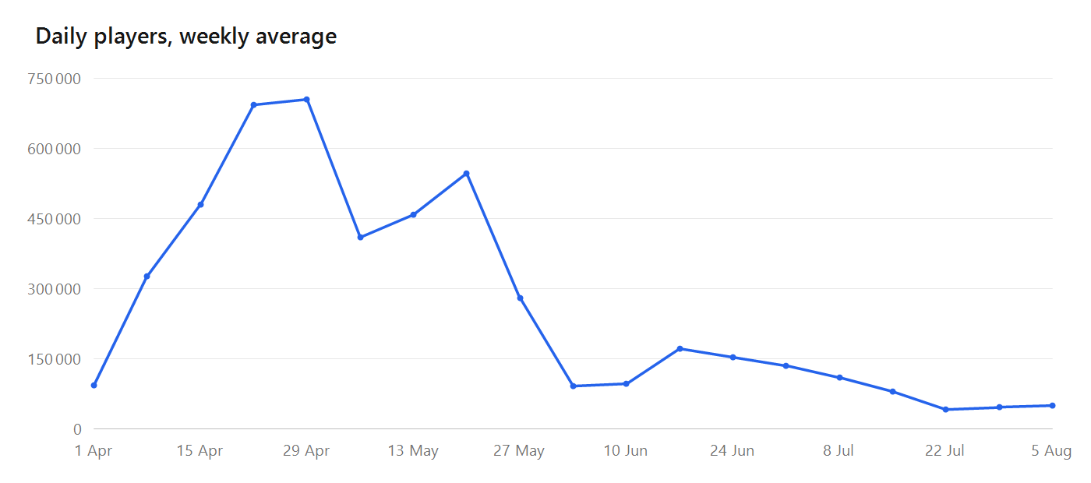
Three cycles of reach given and then withdrawn, each peak smaller than the one before it.

The three cycles
• 1 May: peak of 769,000 daily players. Falls to 353,000 by 16 May.
• Recovers to 538,000 by 28 May, then collapses to 79,000 by 12 June. This is the steepest one, down 81% in twelve days.
• Recovers to 169,000 by 24 June, then drifts down to 108,000 by 18 July.
• Drops to 41,000 by 27 July and has held around 46,000 since.
Impressions track daily players almost exactly through all of this. When Roblox shows the game to fewer people, fewer people play it, and the size of the two moves matches. That is what a distribution change looks like. A broken game looks different, retention falls first and reach follows later.

Why it keeps happening
Put the three retention measures on the same scale and the problem is obvious.
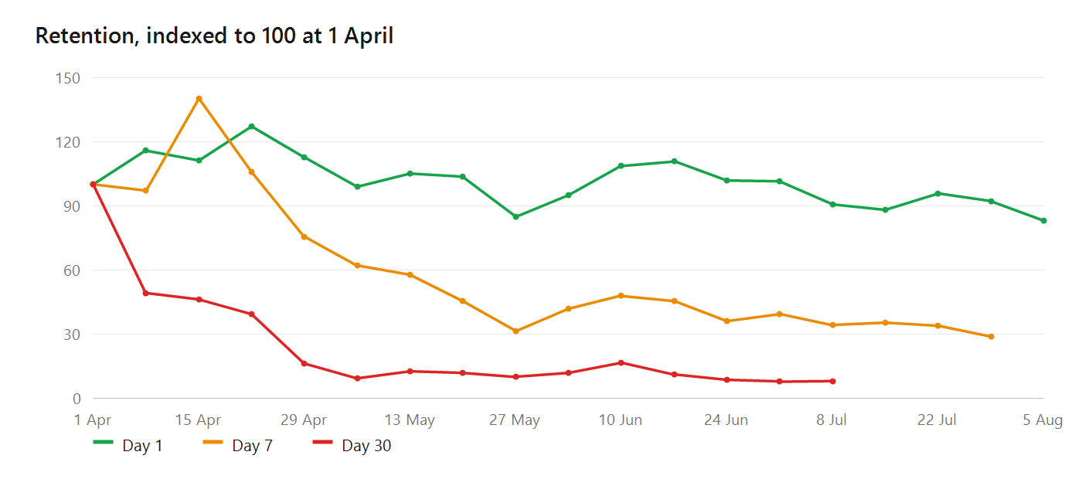
Day 1 is flat across the whole period. Day 7 is down about two thirds and day 30 is down more than 90%.
The first session works. Players arrive, they enjoy it, and one in five comes back the next day, which is above the peer cohort Roblox compares this game against. Then it stops. By day 7 only about 1.5 in 100 are still playing, which is below that cohort, and by day 30 it is 2 in 1000.
That matters more now than it used to. On 15 June Roblox changed how it ranks games for recommendations, moving from a 7 day signal window to 28 days and weighting how many days players keep coming back. Long term retention is now the main thing that earns distribution. This game is weakest at exactly the thing that has become most important.

What is working
• The hook. Day 1 retention has been steady at 16% to 25% for four months and is above the peer cohort median.
• Monetisation per player. ARPDAU and payer conversion are both above the peer cohort median. The game makes good money from the players it has.
• Player sentiment. Roughly 38 upvotes to 10 downvotes, and the complaints are ordinary gripes about a sell confirmation button and shop pricing, nothing about the game being broken.
• The updates are not the problem. Retention and sentiment held steady through every drop while reach collapsed, which is not what a bad update looks like.
There was a server crash event on 31 July and 1 August, about 30,000 crashes a day against a normal day of zero. It was platform side. Roblox rolled out server engine version 732 on 27 and 28 July and an unrelated game crashed identically on the same days. It caused one dip and the game recovered as soon as it stopped.

What to fix
Week one, and only week one until it moves. At 1.5% day 7 retention, about 98 of every 100 players who arrive are gone inside a week. Until that changes, every burst of reach turns into a short spike and then a lower floor than before, which is exactly what the first chart shows happening three times.
1. Give players a reason to come back on day 2, day 3 and day 7. Daily rewards, streaks, progression that does not finish in one sitting, something left unfinished when they log off.
2. Content updates buy reach bursts. The game has already had three. They are not the constraint, and shipping another without fixing week one will produce the same shape a fourth time.
3. Do not use ads for this. Roblox states plainly that it does not count engagement, monetisation or retention from players acquired through ads, curation, friends, search or social when it ranks an experience. Ads buy players, they do not buy distribution back.
4. Judge the fix on day 7 and day 30 retention, not on daily players. Daily players is downstream and lags by weeks, so a retention fix will look like it failed for about a month before it shows up.

What we cannot say
We cannot say why Roblox chose those particular dates to withdraw reach. Roblox does not publish per game ranking decisions and never will. What we can say is that the withdrawals are real, that they match the impression data exactly, and that the game gives Roblox little reason to keep sending players.
We also cannot see before 1 April. Roblox serves roughly four months of this data and the game is older than that, so if there was a launch period with better retention it is no longer retrievable. Crash and performance data is worse, only about 30 days are kept, so technical questions about May or June are permanently unanswerable.

Method
Metrics come from the game's own Creator Dashboard analytics, captured with our tool, so this is data the account is already authorised to see. Figures are checked against Roblox's own CSV exports. Peer cohort comparisons use Roblox's benchmark series, which is its top experiences set rather than a genre median. No game code was read or changed. This game has no funnels defined, so funnel data is absent by design.
Algorithm change reference: https://devforum.roblox.com/t/recommended-for-you-algorithm-improvements-that-better-value-long-term-retention/4684575

